ASSESSMENT 1 PROJECT PROPOSAL.

SIT120-RWA

**Product Summary. Cinemas that shows specific movies.**

I’m going to create a responsive web app where you can find which cinemas show which movies.

In this website a user can come and search for a movie to check which cinemas air it, or he can search for a cinema to see which movies are being aired.

Points that make this a progressive website-

This service is based online and all on a single website. So users don’t have to go to a place physically to find out if the cinema is packed or if the movies aren’t being aired. They can easily search it up.

In Addition to that user can easily book tickets online by going to the specific movie cinemas website within seconds after finding the cinema, rather than scrolling through the web and checking availability on each cinema. This makes it easier for every online ticket booking user as well.

**Asset list.**

There will be a numerous amount of assets that will be used for this project.

|  |  |  |
| --- | --- | --- |
| Asset | How to be used | Detail |
| Index.html | The html holds the foundation for the whole project. Which includes the pages, header, footer and all the vues that will be on this web application. | HTML file. static |
| Style.css | A Style sheet for the index.html  And also the rest of the pages will have a seperate CSS. | CSS for index.html |
| Main.js | The main script to make the project responsive. Also the main file to import and use the other vue components. | JS file for index.html |
| Login.vue | Login page component | Single file component |
| Logout.vue | Logout page componenet. | Single file component |
| Search.vue | Search component. | Single file component |
| Home.vue | Home page component | Single file component |

**Product purpose.**

Purpose of this project is to connect all the cinema websites and rest into one website to make it easier and convenient for any user.

**Target Audience.**

Major movie enthusiasts.

Those who wait for movies to be premiered for the first time and are always going to be hunting for the best seats or the most convenient locations.

Busy people.

Most people don’t have the time to check for a cinema or a movie by visiting a theaters itself,

Some don’t have time or don’t find it convenient to scroll through each and every website to check for availability and movies that are being aired.

**Creativity demonstration.**

Simple and modern design.

There wont be any complicated ways to navigate or search for anything. This web app will be one of the easiest to use for anyone.

Innovative solution.

This project will make online movie hunting much easier for any user. Rather than wasting even a hour online or hours by traveling from place to place ,this web app will make things much easier for any user that will be here.

**User stories.**

|  |  |  |
| --- | --- | --- |
| statement | Acceptance criteria | priority |
| As a user I want to search for a movie and quickly get which cinemas its been showed. | Right after clicking a button in the home page the user can search the movie in the search bar.  After he searches hell get a list of cinemas which the movie will be available on.  After selecting the cinema hell be automatically directed to that specific cinemas website. | High prioroty. |
| As a user I want to know what is the most crowded or most empty cinema. | User searches for the movie or a cinema.  Once what he searches for appears and he clicks the name of it the seats available will be shown. | Medium priority. |
| As a user I’d like to get an update via email when there are any offers that are available | User has to add his email and subscribe.  Once he does hell be automatically sent an email everytime there is a offer for his acc. | Low priority. |

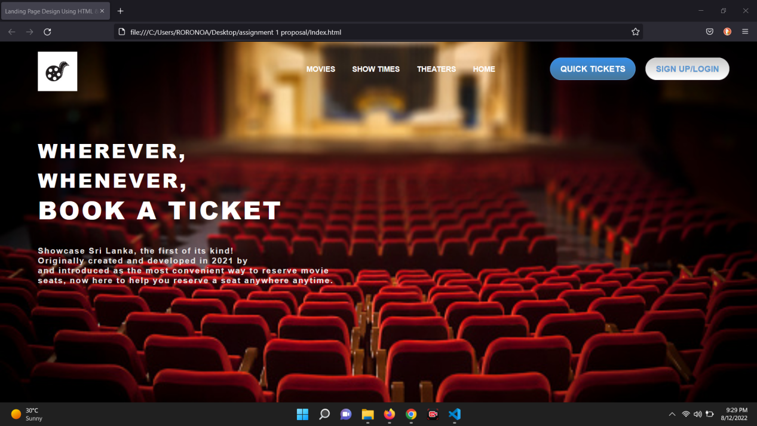

Git hub link : https://github.com/river080/SIT120-RWA-assignments